**Website:** [**www.wynndean.com.au**](http://www.wynndean.com.au) **Email: enquiries @ Wynndean.com.au**

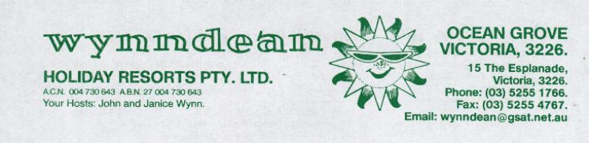

# HappySunSale/Transfer of Caravans “On Site” with replacement requirements.



## Guarantee Deposit Policy for Units with a Maximum Approved Price/Asking Price of less than $5,000

1. Wynndean allows the sale of caravans and annexes “on-site” subject to the adoption of a valuation based Maximum Approved Price and the acceptance of a replacement condition accepted by the purchaser.
2. The replacement condition is advertised on our “Sale Listing” and acknowledged by the purchaser on the “Acknowledgement Form”.
3. Where the MAP/Asking Price is $5,000 or less, then we require a $1,000 guarantee deposit payable at the time of transfer**. This deposit is fully refundable when the replacement or removal is effected by the due date or earlier.**
4. Where the agreed replacement/removal is not undertaken by the nominated date, (subject to an agreed extension being requested and agreed) then this guarantee/deposit will be forfeited and used by Wynndean to demolish, remove and dispose of the caravan/annexe as specified.
5. If the costs of demolition, removal and disposal do not aggregate to the $1,000 then the balance remaining will be refunded.
6. **Re-selling of the purchased on-site unit will not be permitted; whereby clause (4) & (5) shall apply.**